My Little Country Road - Dedicated to Those Fighting For Our Freedom

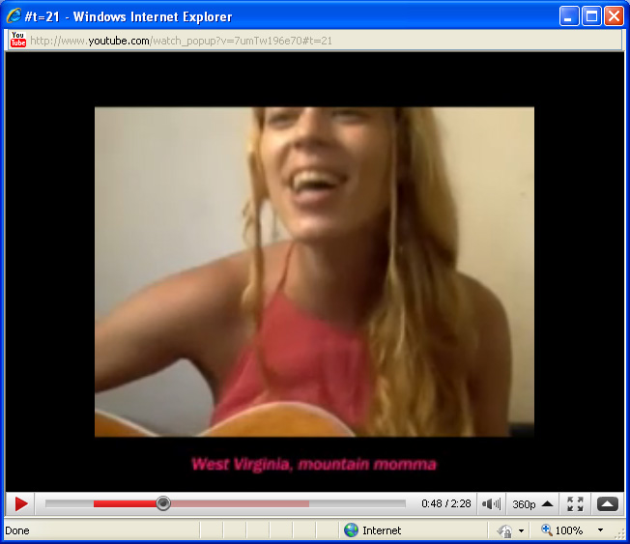
Country Road Freedom Giving it a Go Next Generation

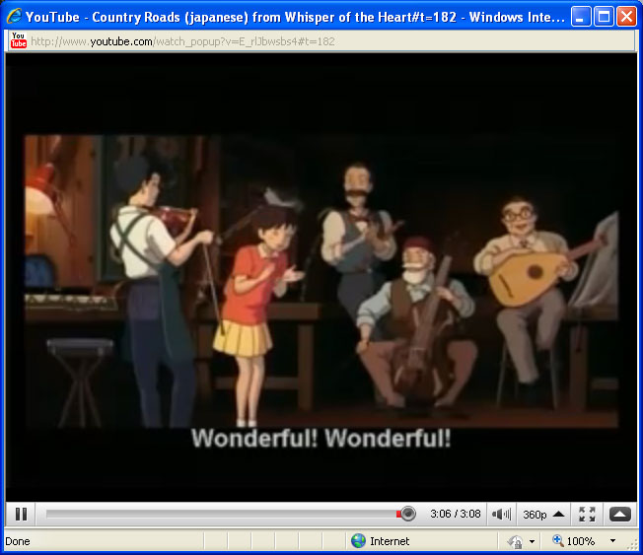
Country Road Freedom in Japan
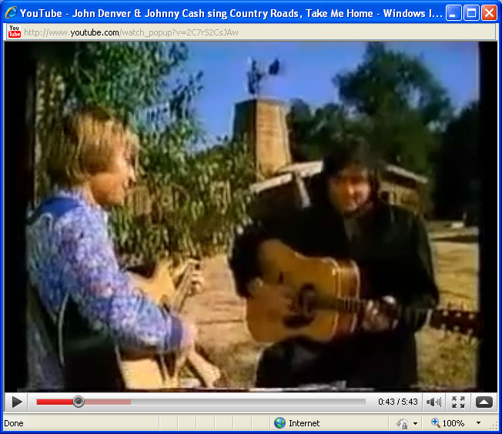
The Genius & Genesis of Country Road Spirit

I live on a little country road

Well nigh three decades of my life

With friends and family surrounding me in my little bungalow

Which has sheltered me from strife

On this little country road

Some ten families also have their abode

And we are all family

Why else would we stay together so long

On this little country road

We meet and greet each other on this little road

On our way to and from work, carrying our heavy loads

Always waiting for the hour to pass

When we can journey home

Down our little country road

And how do we care for this little country road?

Why that is some mystery to me

Outwardly it appears to be covered in gravel, rain and snow

But something else very odd appears to be

What has been bringing me home

All these long long years, in sun, rain, joy and misery

Has not been that little country road

But the love from all those families

We love you!

Jack, Stephanie, Dorothy, Fritz, Enoch Venrick
41250 250th Ave SE

Enumclaw, WA 98022

